MAK DENTAL
480 Redwood Street, Suite #13 Vallejo CA 94590 Tel: 707-554-2600
Homecare Permanent Crowns

Call if sensitivity or discomfort persists
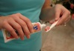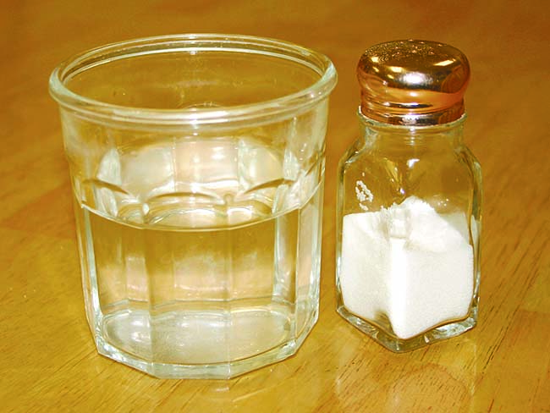

Homecare recommendations
Now that we have placed your permanent crown, it is important to follow these recommendations to ensure the crown’s success:
Chewing and eating
If we used an anesthetic during the procedure, avoid chewing until the numbness has completely worn off.
To protect your crown, avoid chewing ice or other hard objects.
Brushing and flossing
Brush and floss normally, but if your teeth are sensitive to hot, cold, or pressure, you can use a desensitizing toothpaste. If sensitivity increases or persists beyond a few days, call us.
Medication and discomfort
Take antibiotics or other medications only as directed.
To reduce any discomfort or swelling, rinse your mouth three times a day with warm salt water. Use about one teaspoon of salt per glass of warm water. It’s normal for your gums to be sore for several days.
When to call us
Call our office if your bite feels uneven, you have persistent sensitivity or discomfort, or if you have any questions or concerns.

