MAK DENTAL
480 Redwood Street, Suite #13 Vallejo CA 94590 Tel: 707-554-2600
Homecare Permanent Bridges

Wait until numbness completely wears off
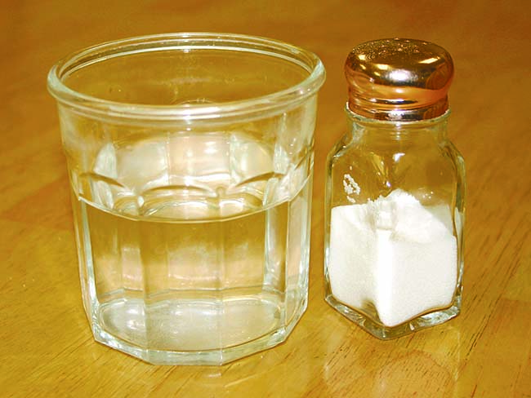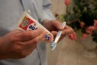

Homecare recommendations
Now that we’ve placed your permanent bridge, it is important to follow these recommendations to ensure its success.
Chewing and eating
If we used an anesthetic during the procedure, avoid chewing until the numbness has completely worn off.
To protect your bridge, avoid chewing ice or other hard objects.
Brushing and flossing
Brush and floss normally, and follow our instructions for keeping the areas around and under the bridge free of plaque and bacteria. We may recommend special floss, brushes, or other cleaning aids.
If your teeth are sensitive to hot, cold, or pressure, use a desensitizing toothpaste. If sensitivity persists beyond a few days, call us.
Medication and discomfort
Take antibiotics or other medications only as directed.
To reduce any discomfort or swelling, rinse your mouth three times a day with warm salt water. Use about one teaspoon of salt per glass of warm water. It is normal for your gums to be sore for several days.
When to call us
Call our office if your bite feels uneven, you have sensitivity or discomfort that increases or continues beyond three or four days, or if you have any questions or concerns.

