MAK DENTAL
480 Redwood Street, Suite #13 Vallejo CA 94590 Tel: 707-554-2600
Homecare Temporary Crowns
Call if sensitivity or discomfort persists
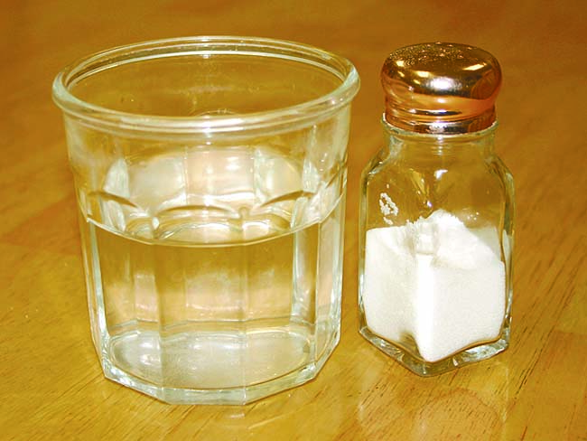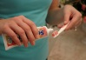

Chewing and eating
Now that we have placed a temporary crown, it is important to follow these recommendations to ensure the success of your final restoration.
If we used an anesthetic during the procedure, avoid chewing until the numbness has completely worn off.
Avoid chewing for at least one half-hour to allow the temporary cement to set.
To keep your temporary crown in place, avoid eating hard or sticky foods, especially chewing gum. If possible, chew only on the opposite side of your mouth.
Brushing and flossing
Brush normally, but floss very carefully. Remove floss from the side to prevent removal of the temporary crown. In some cases, we may advise you to avoid flossing around the temporary crown.
If your teeth are sensitive to hot, cold, or pressure, use desensitizing toothpaste. If sensitivity increases or persists beyond a few days, call us.
Medication and discomfort
Take antibiotics or other medications only as directed.
To reduce any discomfort or swelling, rinse your mouth three times a day with warm salt water. Use about one teaspoon of salt per glass of warm water. It is normal for your gums to be sore for several days.
When to call us
Call us if your temporary crown comes off. Save the temporary, so it can be re-cemented. It is very important for the proper fit of your final crown that your temporary crown stay in place.
Call our office if your bite feels uneven, you have sensitivity or discomfort that increases or continues beyond three or four days, or if you have any questions or concerns.

