MAK DENTAL
480 Redwood Street, Suite #13 Vallejo CA 94590 Tel: 707-554-2600
Homecare Temporary Bridges

Wait until numbness is completely worn off
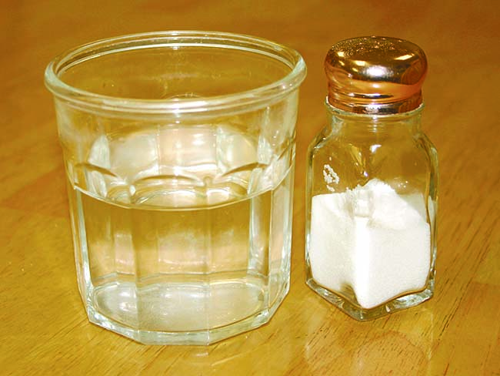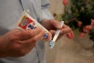

Chewing and eating
Now that we have placed a temporary bridge, it is important to follow these recommendations to ensure the success of your final restoration.
If we used an anesthetic during the procedure, avoid chewing until the numbness has completely worn off.
Avoid chewing for at least one half-hour to allow the temporary cement to set.
To keep your temporary bridge in place, avoid eating hard or sticky foods, especially chewing gum. If possible, chew only on the opposite side of your mouth.
Brushing and flossing
Brush normally, but floss very carefully. To keep the temporary in place, remove floss by pulling it forward and away from you, instead of sliding it between the teeth. We may recommend special floss, brushes, or other cleaning aids to keep the area free of plaque and bacteria.
If your teeth are sensitive to hot, cold, or pressure, use desensitizing toothpaste. If sensitivity increases or persists beyond a few days, call us.
Medication and discomfort
Take antibiotics or other medications only as directed. To reduce any discomfort or swelling, rinse your mouth three times a day with warm salt water. Use about one teaspoon of salt per glass of warm water. It is normal for your gums to be sore for several days.
When to call us
Call us if your temporary bridge comes off. Save the temporary, so it can be re-cemented. It is very important for the proper fit of your final bridge that your temporary stay in place.
Call our office if your bite feels uneven, you have sensitivity or discomfort that increases or continues beyond three or four days, or if you have any questions or concerns.

