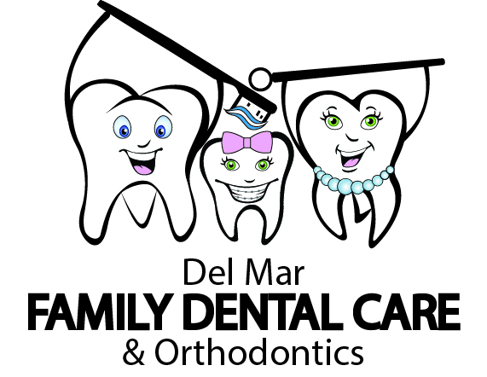
Patient Information
Patient’s Name:
Address: Apt#:
City: State: Zip Code:
Ph/Cell #: Work #: Email :
Sex: M F Age: D.O.B.:
SSN: Insurance Name:
Group#______________________ MemberID#____________________________
Responsible Party if the Patient is under 18 years
Name:
Sex: M F Age: D.O.B.:
SSN: Insurance/ CHP⁺/Medicaid#:
Phone #: Relation to Patient:
Patient Consent for Treatment
I hereby apply and give permission for diagnosis and/or treatment to Del Mar Family Dental Care. For myself or the minor child named on this application. Such treatment may include the rending of:
Anesthesia, Medications or Prescriptions, Radiographs, Model, Extractions, Restoration of teeth, Sealants, Endodontic (root canals), Orthodontics (braces), Periodontist (gum surgery), in office bleaching or take home trays.
It is further understood that the medical/health information presented in this application is an accurate presentation of my, or minor child present medical/health status.

Patient (Guardian) Signature Date
Print Name ________________________________________

