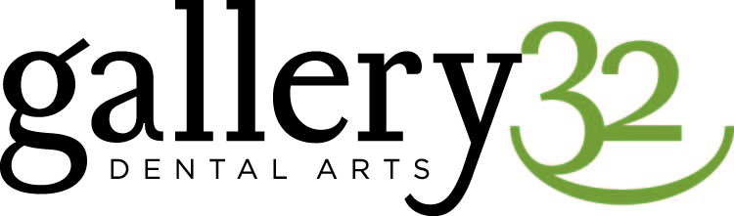
Scott D. Allman, D.D.S., P.C.
Restorative and General Dentistry

ACKNOWLEDGEMENT OF RECEIPT OF NOTICE OF PRIVACY PRACTICES

*You May Refuse To Sign This Acknowledgement*

I, ________________________________________________, have received a copy of this office’s Notice of Privacy Practices.

______________________________________________________________
Please Print Name

______________________________________________________________
Signature Date

---------------------------------------------------------------------------------------------------------------------
FOR OFFICE USE ONLY
---------------------------------------------------------------------------------------------------------------------

We attempted to obtain written acknowledgement or receipt of our Notice of Privacy Practices, but acknowledgement could not be obtained because:

- Individual refused to sign

- Communication barriers prohibited obtaining acknowledgement

- An emergency situation prevented us from obtaining acknowledgement

- Other: (Please Specify): ________________________________________________________________________________________________________________________________________________________________________________________________________________________

