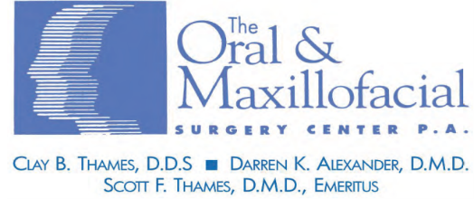

**DENTAL INSURANCE**

**Primary Dental Insurance Secondary Dental Insurance**

Ins. Co. Name:_________________________________ Ins. Co. Name:___________________________________   
ID #:_________________________________________ ID#:____________________________________________   
Group#:______________________________________ Group#:_________________________________________   
Address:_____________________________________ Address:________________________________________   
Tel. (______)_____________________ Tel. (______)_______________________________   
Insured Party:_________________________________ Insured Party:_____________________________________ Employer:_____________________________________ Employer:________________________________________  
S.S.#:_________________ Date of Birth:____________ S.S.#:__________________ Date of Birth:______________  
Address:______________________________________ Address:_________________________________________   
Tel. (____)____________ Relation: Self / Spouse / Child Tel. (____)______________ Relation: Self / Spouse / Child

**MEDICAL INSURANCE**

**Primary Medical Insurance Secondary Medical Insurance**

Ins. Co. Name:_________________________________ Ins. Co. Name:___________________________________   
ID #:_________________________________________ ID#:____________________________________________   
Group#:______________________________________ Group#:_________________________________________   
Address:_____________________________________ Address:________________________________________   
Tel. (______)_____________________ Tel. (______)_______________________________   
Insured Party:_________________________________ Insured Party:_____________________________________ Employer:_____________________________________ Employer:________________________________________  
S.S.#:_________________ Date of Birth:____________ S.S.#:__________________ Date of Birth:______________  
Address:______________________________________ Address:_________________________________________   
Tel. (____)____________ Relation: Self / Spouse / Child Tel. (____)______________ Relation: Self / Spouse / Child

**NOTE TO INSURED**: Verification of your insurance is not a guarantee of payment! Claims are based on Usual Customary and Reasonable Fees, which vary from company to company. I understand and agree that I will be responsible for any balance due that The Oral & Maxillofacial Surgery Center, PA is unable to collect from my insurance carrier for whatever reason.

Guarantor: ________________________________________________________ Date: ____________________________

REV 2021